🔭 Astronomy Jokes 🔭
20 Curriculum-Linked Jokes
Each joke connects to a key learning point

Contents
1. How do you organise a space party? [Planets in our solar system]
2. Why did the sun go to school? [Stellar classification: main sequence]
3. What kind of music do planets listen to? [Orbital mechanics and Kepler's laws]
4. Why did the astronaut break up with the moon? [The Moon: Earth's natural satellite]
5. What do you call a tick on the moon? [Lunar surface conditions: no air]
6. Why is Venus so hot? [Greenhouse effect on Venus]
7. What did Mars say to Saturn? [Saturn's ring system of ice and rock]
8. Why can't you trust the gravity on Jupiter? [Gravity and planetary mass]
9. How do astronauts serve dinner? [Satellites: natural and artificial]
10. What's an astronaut's favourite key on the keyboard? [Space exploration and technology]
11. Why did the comet go to the hairdresser? [Comet structure: nucleus, coma, tail]
12. What do you call a star that's really rude? [Stellar evolution: red giant stage]
13. Why don't aliens eat clowns? [Fermi Paradox: where is everybody?]
14. What happens when a star dies dramatically? [Supernovae: explosive stellar death]
15. Why was Pluto kicked out of the planet club? [Dwarf planets and the 2006 reclassification]
16. What's at the centre of our galaxy? [Black holes at galactic centres]
17. Why do astronomers love the dark? [Light pollution and observational astronomy]
18. What travels at 300,000 km/s? [Speed of light and light-years]
19. Why was the nebula so colourful? [Nebulae: birthplaces of stars]
20. What did the Big Bang say? [Big Bang theory and expanding universe]

Joke #1
📌 Curriculum Link: Planets in our solar system
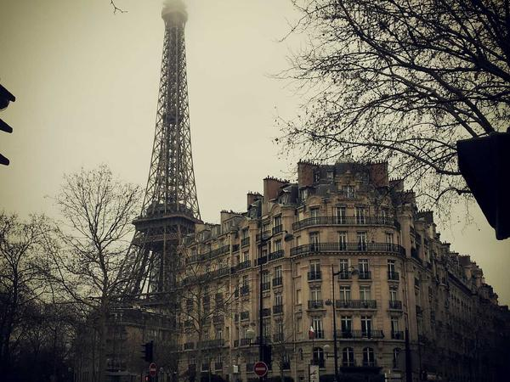
Q: How do you organise a space party?
A: You planet!
💡 Discussion: Why is this joke funny? What does it tell us about "Planets in our solar system"? Can you explain the concept to a partner?

Joke #2
📌 Curriculum Link: Stellar classification: main sequence

Q: Why did the sun go to school?
A: To get a little brighter — it's a main sequence star!
💡 Discussion: Why is this joke funny? What does it tell us about "Stellar classification: main sequence"? Can you explain the concept to a partner?

Joke #3
📌 Curriculum Link: Orbital mechanics and Kepler's laws

Q: What kind of music do planets listen to?
A: Neptunes! (And they orbit in ellipses)
💡 Discussion: Why is this joke funny? What does it tell us about "Orbital mechanics and Kepler's laws"? Can you explain the concept to a partner?

Joke #4
📌 Curriculum Link: The Moon: Earth's natural satellite

Q: Why did the astronaut break up with the moon?
A: Because they needed more space!
💡 Discussion: Why is this joke funny? What does it tell us about "The Moon: Earth's natural satellite"? Can you explain the concept to a partner?

Joke #5
📌 Curriculum Link: Lunar surface conditions: no air

Q: What do you call a tick on the moon?
A: A luna-tick! And the moon has no atmosphere.
💡 Discussion: Why is this joke funny? What does it tell us about "Lunar surface conditions: no air"? Can you explain the concept to a partner?

Joke #6
📌 Curriculum Link: Greenhouse effect on Venus

Q: Why is Venus so hot?
A: Not just because it's close to the Sun — it's the greenhouse effect!
💡 Discussion: Why is this joke funny? What does it tell us about "Greenhouse effect on Venus"? Can you explain the concept to a partner?

Joke #7
📌 Curriculum Link: Saturn's ring system of ice and rock
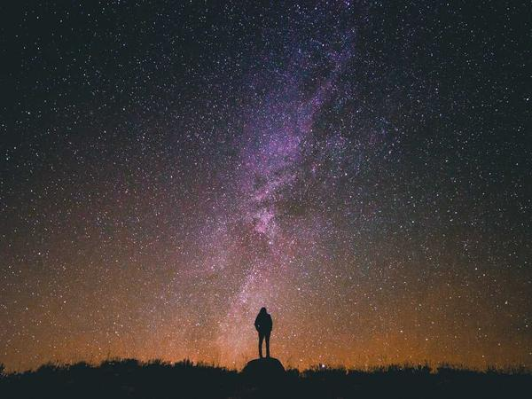
Q: What did Mars say to Saturn?
A: Give me a ring sometime!
💡 Discussion: Why is this joke funny? What does it tell us about "Saturn's ring system of ice and rock"? Can you explain the concept to a partner?

Joke #8
📌 Curriculum Link: Gravity and planetary mass

Q: Why can't you trust the gravity on Jupiter?
A: Because it's massive — 318 times Earth's mass!
💡 Discussion: Why is this joke funny? What does it tell us about "Gravity and planetary mass"? Can you explain the concept to a partner?

Joke #9
📌 Curriculum Link: Satellites: natural and artificial

Q: How do astronauts serve dinner?
A: On satellite dishes!
💡 Discussion: Why is this joke funny? What does it tell us about "Satellites: natural and artificial"? Can you explain the concept to a partner?

Joke #10
📌 Curriculum Link: Space exploration and technology
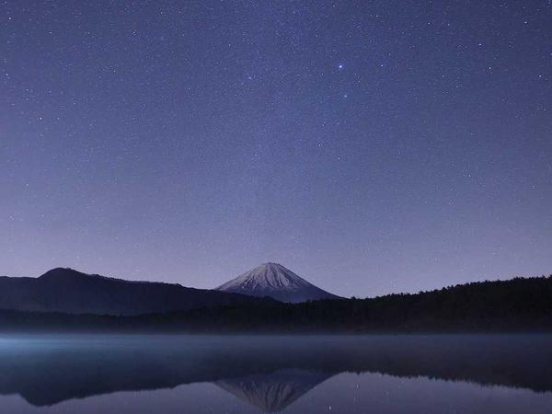
Q: What's an astronaut's favourite key on the keyboard?
A: The space bar!
💡 Discussion: Why is this joke funny? What does it tell us about "Space exploration and technology"? Can you explain the concept to a partner?

Joke #11
📌 Curriculum Link: Comet structure: nucleus, coma, tail
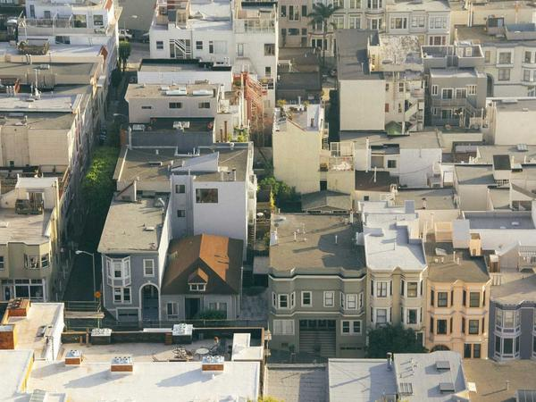
Q: Why did the comet go to the hairdresser?
A: To get its tail styled — comets have dust and gas tails!
💡 Discussion: Why is this joke funny? What does it tell us about "Comet structure: nucleus, coma, tail"? Can you explain the concept to a partner?

Joke #12
📌 Curriculum Link: Stellar evolution: red giant stage

Q: What do you call a star that's really rude?
A: A red giant — they're bloated and temperamental!
💡 Discussion: Why is this joke funny? What does it tell us about "Stellar evolution: red giant stage"? Can you explain the concept to a partner?

Joke #13
📌 Curriculum Link: Fermi Paradox: where is everybody?

Q: Why don't aliens eat clowns?
A: Because they taste funny — but do aliens exist? That's the Fermi Paradox!
💡 Discussion: Why is this joke funny? What does it tell us about "Fermi Paradox: where is everybody?"? Can you explain the concept to a partner?

Joke #14
📌 Curriculum Link: Supernovae: explosive stellar death

Q: What happens when a star dies dramatically?
A: It goes out with a bang — a supernova!
💡 Discussion: Why is this joke funny? What does it tell us about "Supernovae: explosive stellar death"? Can you explain the concept to a partner?

Joke #15
📌 Curriculum Link: Dwarf planets and the 2006 reclassification

Q: Why was Pluto kicked out of the planet club?
A: Because it didn't clear its orbit — IAU 2006!
💡 Discussion: Why is this joke funny? What does it tell us about "Dwarf planets and the 2006 reclassification"? Can you explain the concept to a partner?

Joke #16
📌 Curriculum Link: Black holes at galactic centres

Q: What's at the centre of our galaxy?
A: A supermassive black hole — Sagittarius A*!
💡 Discussion: Why is this joke funny? What does it tell us about "Black holes at galactic centres"? Can you explain the concept to a partner?

Joke #17
📌 Curriculum Link: Light pollution and observational astronomy
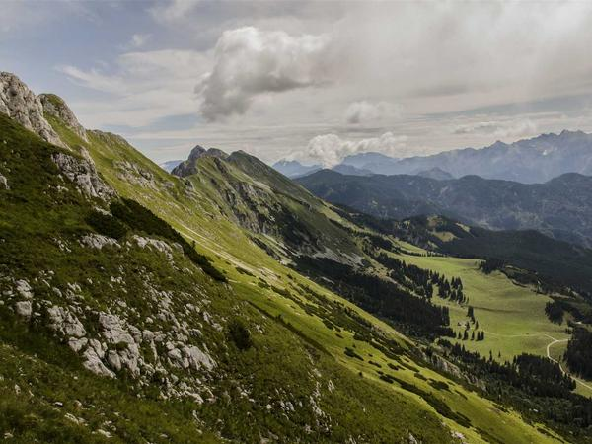
Q: Why do astronomers love the dark?
A: Because light pollution hides the stars!
💡 Discussion: Why is this joke funny? What does it tell us about "Light pollution and observational astronomy"? Can you explain the concept to a partner?

Joke #18
📌 Curriculum Link: Speed of light and light-years

Q: What travels at 300,000 km/s?
A: Light — and it takes 8 minutes from the Sun to Earth!
💡 Discussion: Why is this joke funny? What does it tell us about "Speed of light and light-years"? Can you explain the concept to a partner?

Joke #19
📌 Curriculum Link: Nebulae: birthplaces of stars

Q: Why was the nebula so colourful?
A: Because it's a stellar nursery full of glowing gas!
💡 Discussion: Why is this joke funny? What does it tell us about "Nebulae: birthplaces of stars"? Can you explain the concept to a partner?

Joke #20
📌 Curriculum Link: Big Bang theory and expanding universe

Q: What did the Big Bang say?
A: Let me expand on that — the universe is still growing!
💡 Discussion: Why is this joke funny? What does it tell us about "Big Bang theory and expanding universe"? Can you explain the concept to a partner?

